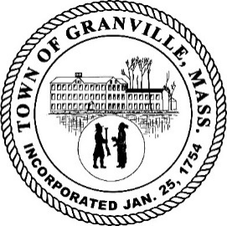

TOWN OF GRANVILLE
P.O. Box 247
707 Main Road
Granville, MA 01034

(413) 357-8585 (phone)
(413) 357-6002 (fax)

OFFICE OF THE TOWN ADMINISTRATOR

January 23, 2023

The Town of Granville is seeking applicants for a Boards and Committees clerk who shall take and record minutes of public meetings and report to the Town Administrator.

BOARDS AND COMMITTEES CLERK – Job description and duties

The Boards and Committees Clerk shall be responsible for taking minutes, whether by hand or recording, transcribing the minutes into document form for adoption and preservation in accordance with MGL. Minutes need to be action minutes and generally comprise what occurs at the meeting, including members and public attending, discussion topics and any votes occurring.

While primarily the clerk will work for the Selectboard which meets almost every Monday throughout the year, the clerk may be needed to perform similar duties for the Planning Board, Zoning Board of Appeals, Conservation Commission, Town Meeting, or others which may meet on other days of the week, but far less frequently. These Boards and Commissions generally meet in the evenings, so the ability to attend evening meetings and drive at night is necessary.

Duties include attendings meetings and public hearings; settings up meeting rooms; operates various equipment including listening devices, recording equipment, laptop computer; takes minutes and/or audio taping of various meetings as needed; prepares draft and final minutes. The Clerk should be proficient with word document programs and use a computer. Confidentiality and discretion, where applicable, of topics under consideration or in Executive Session is essential.

The rate of pay is a piecemeal rate of $100.00 per meeting to attend, record, transcribe and produce draft and final minutes. Additional similar duties office work may be assigned including scanning, transcribing, filing at a rate of $15.00/hr. as part-time employee not to exceed 10 hours/week.

Education & experience: Minimum High School diploma or GED required. No prior experience necessary but understanding of municipal government and /or secretarial work preferred.

Letters of interest will be accepted via email at townadministrator@townofgranville.org with Subject Line: CLERK or by mail at drop box at Town Hall or PO Box 247, Granville, MA 01034 Attn: CLERK. Position will be open until filled. FSLA Exempt. Granville is an AA/EOE.

